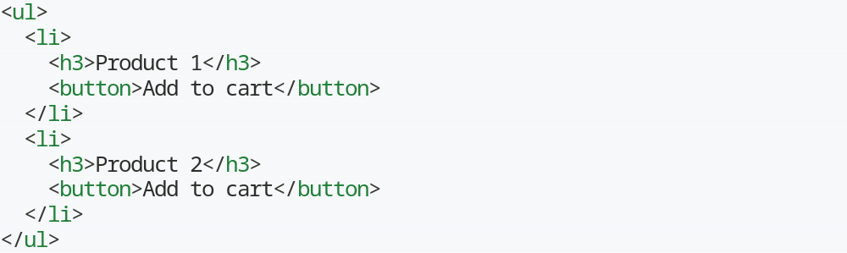Matching Inside Locator
Save locator in one reference and use again it to locate another element inside it.
1. First locate “Product 2” list element
2. Then locate “Add to cart” button
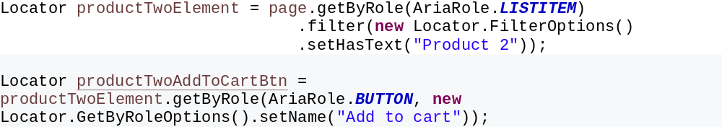

Matching Two Locators Simultaneously
- Use of “and” method
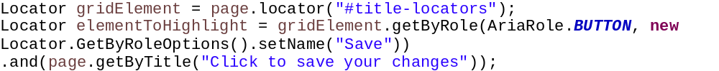
Matching one of the two locators
- Use of “or” method
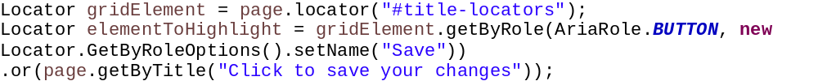
Use of visible() method
- When visible() method is invoked on locator then it will locate only element that has “display” css as

